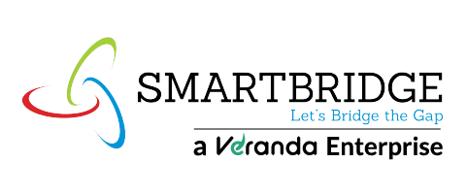

Model Development Phase Template
Date | 15 March 2024
Team ID | LTVIP2026TMIDS76529
Project Title | Advancing Nutrition Science through GeminiAI  (NutriGen)
Maximum Marks | 5 Marks
Feature Selection Report Template
In the forthcoming update, each feature will be accompanied by a brief description. Users will indicate whether it's selected or not, providing reasoning for their decision. This process will streamline decision-making and enhance transparency in feature selection.
S.No | Feature Name | Description | Selected  (Yes/No) | Reasoning
1 | Personalized Meal  Plan Generator | Generates weekly meal plans based on user preferences, dietary restrictions, allergies, and health conditions | Yes | Core functionality of the application. Provides high user value and differentiates the product through AI-powered customization.
2 | Recipe & Grocery  List Generator | Automatically creates recipes and categorized grocery lists for planned meals | Yes | Enhances user convenience and supports practical implementation of meal plans. Improves usability.
3 | Macronutrient  Analysis | Provides protein, fat, carbohydrate breakdown | Yes | Essential for users tracking fitness, weight loss, or muscle gain goals.
4 | Micronutrient  Analysis | Displays vitamins and mineral content | Yes | Adds scientific depth and promotes informed nutritional decisions.
5 | Calorie Calculator | Calculates calorie content for meals and snacks | Yes | Important for weight management and dietary tracking.
6 | Barcode Scanning | Allows users to scan packaged food for instant nutritional info | Yes | Increases usability and realtime practicality. Makes the app modern and interactive.
7 | Virtual Nutrition  Coaching Chatbot | AI-powered chatbot providing personalized advice and Q&A support | Yes | Expands user engagement and democratizes access to nutrition expertise.
8 | Activity-Level  Based  Recommendations | Adjusts meal plans based on sedentary, moderate, or active lifestyle | Yes | Improves personalization and accuracy of recommendations.
9 | Progress Tracking  Dashboard | Tracks nutritional intake and goal progress over time | Yes | Encourages habit formation and long-term engagement.

